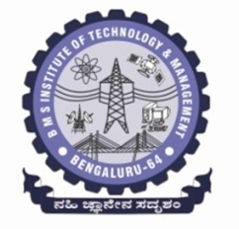**BMS Institute of Technology and Management**

**(An Autonomous Institution, Affiliated to VTU, Belagavi)**

**Department of Master of Computer Applications**

**(Accredited by NBA, New Delhi)**

**Alternate Assessment Tool (AAT) #**

|  |  |  |  |
| --- | --- | --- | --- |
| **USN** |  | **Student Name** |  |
| **Course Code** |  | **Course Title** |  |
| **Semester** | 1st | **Academic Year** | 2022-23 |
| **Date of Submission** |  | **Number of Pages Submitted** |  |

|  |
| --- |
| **AAT Question or Topic or Problem Statement**   1. **Write a program to calculate area of square and rectangle.** 2. **Write a program to perform string concatenation.** 3. **Write a program to read c character in upper case and print it in lower case.** 4. **Write a program to calculate simple interest and compound interest** 5. **Write a program to calculate salary of an employee given his basic pay (to be entered by the user), HRA=10% of basic, TA=5% of basic. Define HRA and TA as constants and use them to calculate the salary of the employee.** 6. **Write a program to take input from the user and then check whether it is a number or a character. If it is a character, determine whether it is in uppercase or lowercase.** 7. **Write a program to reverse a number.** 8. **Write a program to print the multiplication table of n, where n is entered by the user.** |